The Thermal Impacts of Kinnickinnic River
Hydropower Dams and Impoundments in River Falls, WI

Kiap-TU-Wish Temperature Monitoring Network

Since 1992, the Kiap-TU-Wish Chapter of Trout Unlimited has been conducting temperature monitoring of the Kinnickinnic River (Kinni) at 5 locations in the vicinity of River Falls, Wisconsin (Figure 1). Temperature monitoring has typically been conducted during the mid-April to mid-October period each year, using electronic instrumentation that continuously measures river temperatures at 10-minute intervals. The temperature data obtained at each monitoring site can be compared to critical temperature thresholds that must be maintained to support healthy coldwater communities in the Kinnickinnic River.

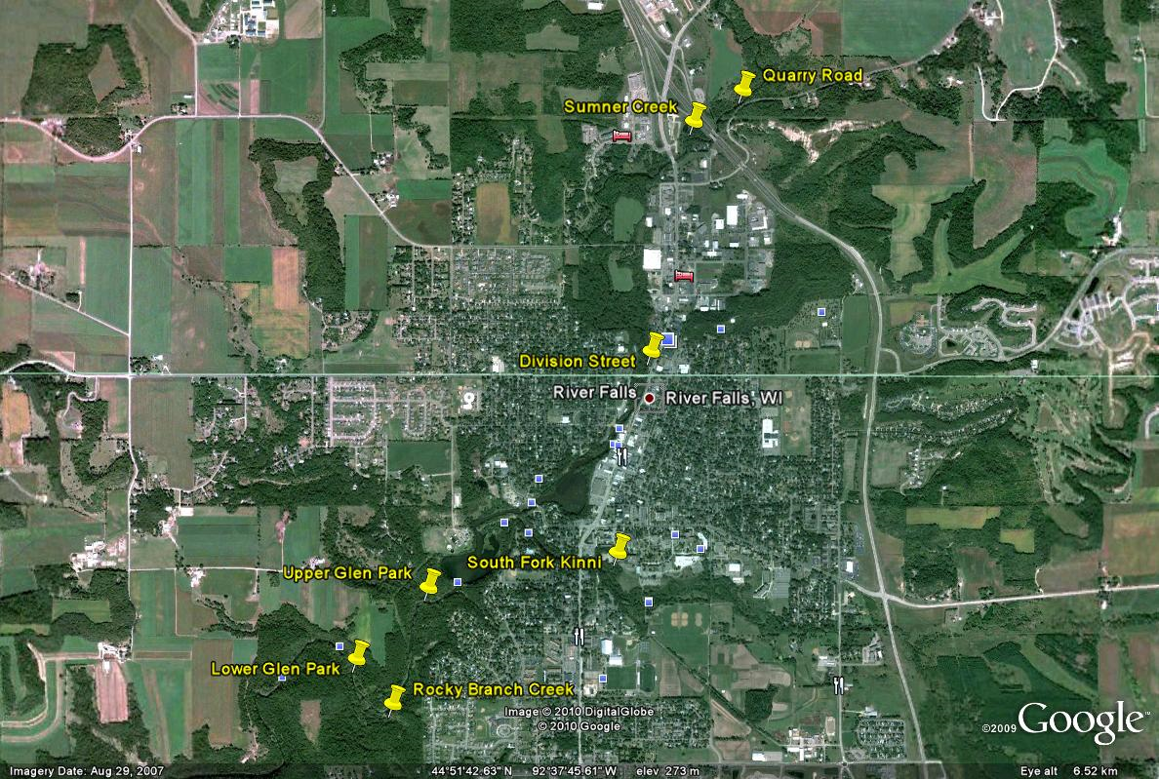

Figure 1. Kiap-TU-Wish temperature monitoring sites on the Kinnickinnic River and tributaries in River Falls,
WI.

The temperature monitoring data obtained at two Kinnickinnic River monitoring sites can be used to evaluate the thermal impacts of the two impoundments (Lake George and Lake Louise) created by the City of River Falls hydropower facilities (Junction Falls and Powell Falls Dams). The monitoring site at Division Street is a reference or control site located upstream from the two hydropower impoundments, thereby reflecting unimpacted river temperatures. The monitoring site at Upper Glen Park is an impact site situated downstream from the two hydropower impoundments, reflecting their warming influence.

Thermal Impacts of Kinnickinnic River Dams: 1994-2020

An assessment by Kiap-TU-Wish of the temperature monitoring data obtained at the Division Street and Upper Glen Park monitoring sites indicates that summer (June-August) river temperatures are notably higher downstream from the two hydropower impoundments. During the 1994-2020 period of record, the downstream summer average temperature at Upper Glen Park was 2.2º C (3.9° F) warmer than the upstream summer average temperature at Division Street (Figure 2). This temperature difference is even greater in July (the warmest summer month), with the downstream temperature 2.4º C (4.4° F) higher than the upstream temperature (Figure 3). Furthermore, throughout the summer period, the downstream temperature at Upper Glen Park more frequently exceeds the critical temperature thresholds that support healthy coldwater trout and insect communities in the Kinni. A long-term warming trend in water temperature is already occurring in the Kinnickinnic River. However, the thermal impacts of the two hydropower dams and impoundments will make the downstream river much more sensitive to any future impacts of climate change. Dam removal and river restoration in River Falls are critical to ensure a coldwater future for the Kinni.

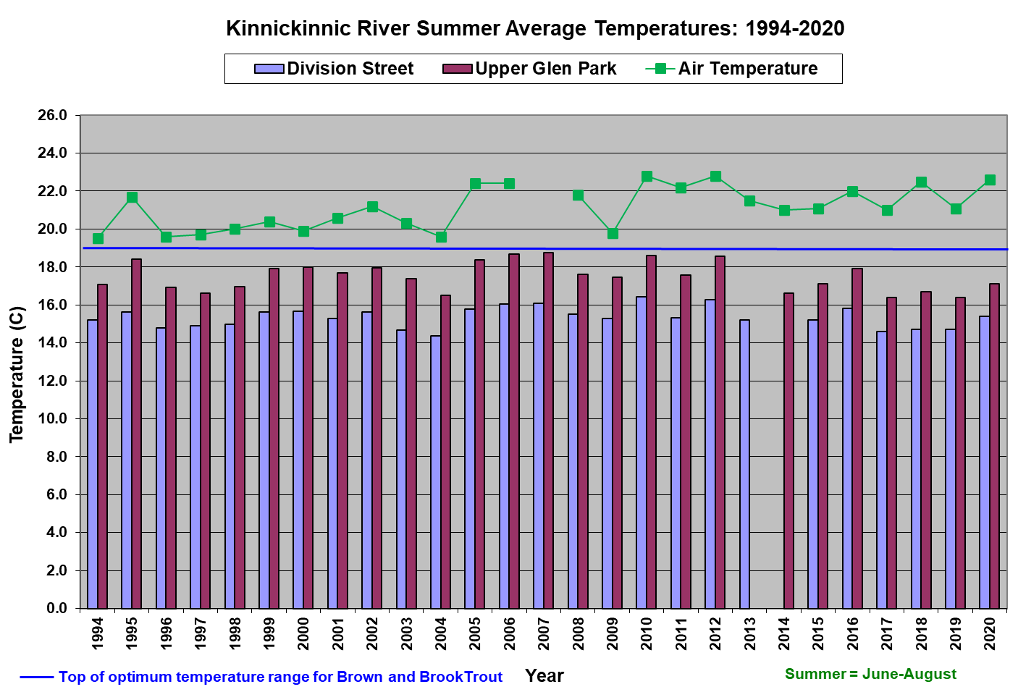

Figure 2. Kinnickinnic River summer average temperatures at Division Street and Upper Glen Park, 1994-2020.
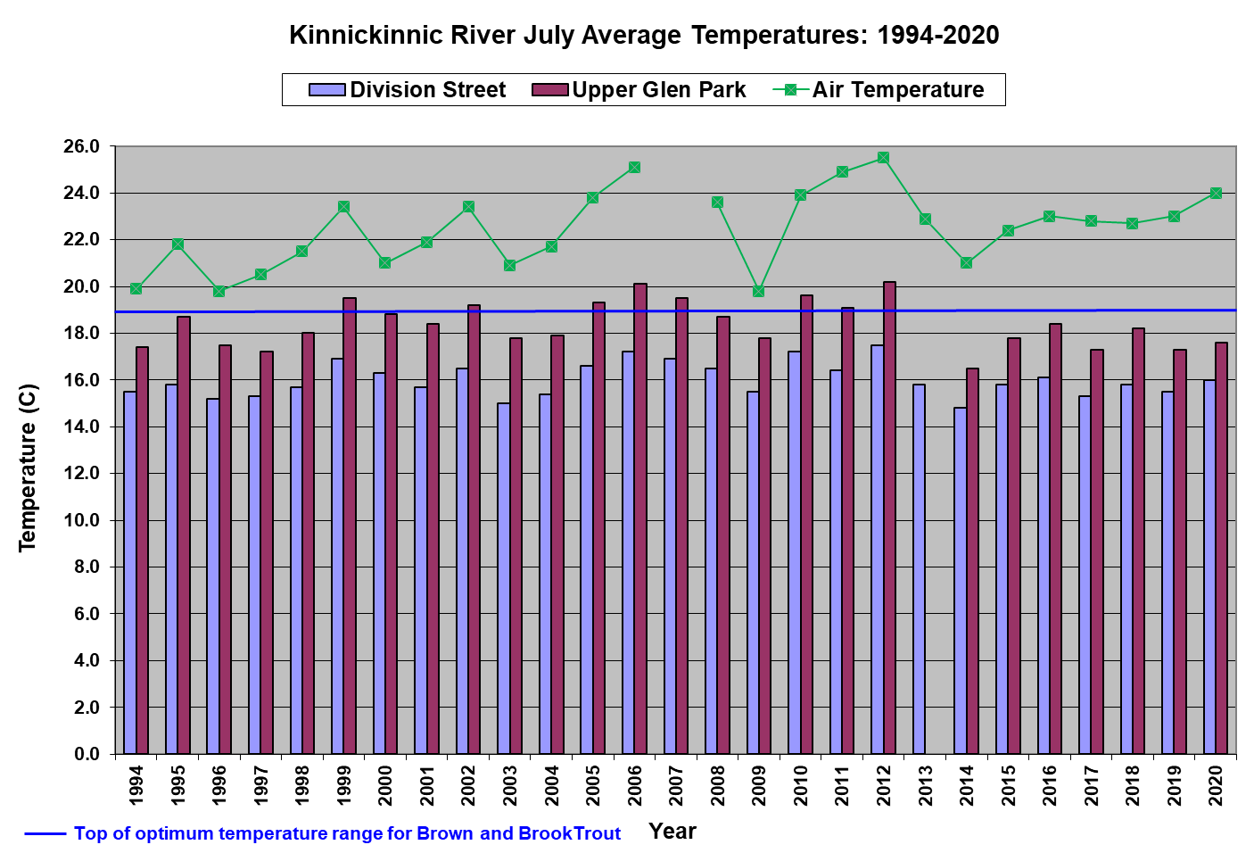

Figure 3. Kinnickinnic River July average temperatures at Division Street and Upper Glen Park, 1994-2020.

Future of the Kinnickinnic River Dams

City of River Falls Council Resolution No. 6234 (February 27, 2018) authorized the removal of both Kinnickinnic River dams (Junction Falls and Powell Falls):

- The City will remove the Powell Falls Dam and complete associated stream restoration by 2026.
- The City will remove the Junction Falls Dam and complete associated stream restoration by 2035-2040. If ecological conditions on the Kinnickinnic River degrade to a point where the need for this project becomes more immediate, an earlier date may be chosen.

The current Federal Energy Regulatory Commission (FERC) license for the River Falls hydroelectric project expires in 2023. With the decision to remove the Powell Falls Dam, the City requested that FERC release the Powell Falls Development from the current license; and FERC granted this request in February 2022. The City then applied under Wisconsin Department of Natural Resources (WDNR) jurisdiction to remove the Powell Falls Dam. If the City is successful in the application and permitting process, Powell Falls Dam removal and river restoration through the former Lake Louise are expected to be complete by 2026. The City is in the process of renewing the FERC license for the Junction Falls Development and will continue to operate it until 2035, at which time the Junction Falls Dam will also be removed between 2035 and 2040.

2020: Kinnickinnic River Flood, Damage to Powell Falls Dam, and Lake Louise Drawdown

As a result of a large rain event (6.75 inches) in River Falls from June 28-29, 2020, major flooding occurred within the Kinnickinnic River Watershed and the surrounding areas. At USGS flow gage 05342000, located at the County Road F crossing in Pierce County, Kinnickinnic River discharge peaked at 6,450 cfs at 2:45 PM on June 29 (Figure 4). This peak flow is approximately the 5% annual exceedance probability event (6,550 cfs) (USACE 2021).

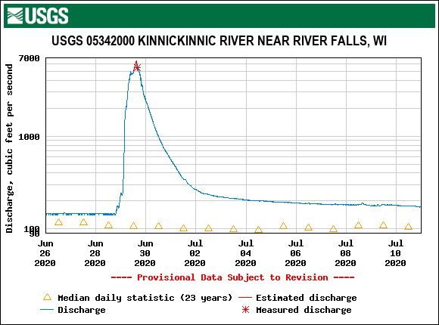

Figure 4. USGS hydrograph of the June 28-29, 2020 flood on the Kinnickinnic River.

The June 28-29 flood event damaged the Powell Falls Dam. Due to public safety concerns, the City of River Falls requested permission from FERC for a Lake Louise drawdown, to allow for a dam inspection. FERC and WDNR approved the drawdown, which was conducted from October 2-15, 2020, along with water quality monitoring. The subsequent dam inspection by Ayres noted damage to the right wing wall and sluice gate. At a January 19, 2021 joint workshop, the River Falls Utility Advisory Board and the City Council determined that the Powell Falls Dam will not be repaired, and the Lake Louise drawdown will continue until dam removal and river restoration occur. After the October 2020 drawdown, a new Kinnickinnic River emerged in the former Lake Louise, for the first time since 1903 (Figure 5).
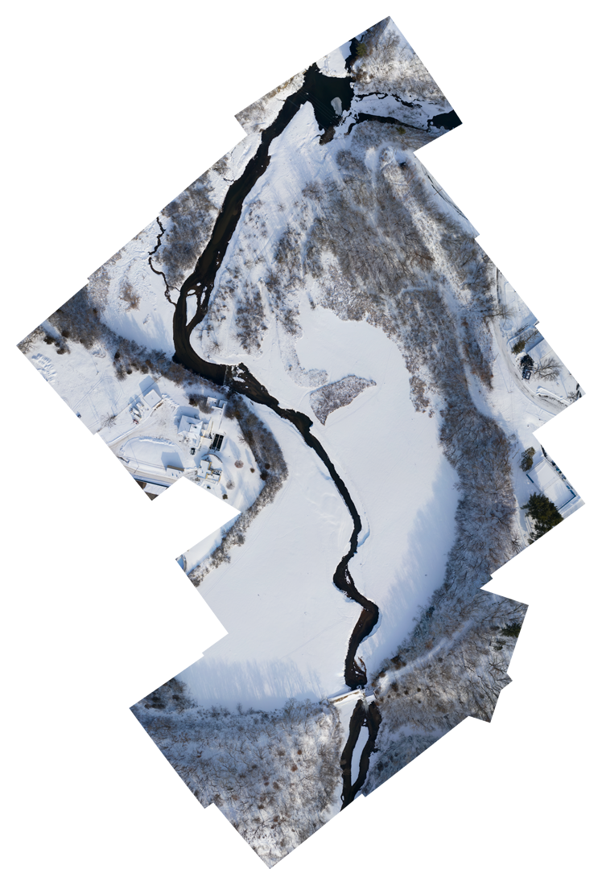
Powell Falls Dam
South Fork Kinni
Drone Imagery by River Sky Drones
Judie Foster Babcock
David Foster Babcock
Figure 5. A new Kinnickinnic River flows through the former Lake Louise impoundment in early 2021.

Kinnickinnic River Temperature Improvements in 2021

The drawdown of Lake Louise in 2020 removed the impoundment’s historical thermal impact on the lower Kinnickinnic River, and Kiap-TU-Wish monitoring in 2021 documented the extent of the subsequent downstream temperature improvement.

In the summer of 2021, the difference between the upstream Kinnickinnic River temperature at Division Street and the downstream temperature at Upper Glen Park was the smallest since monitoring began in 1994 (Figures 6 and 7). Despite the warmest summer since 1994, the summer average temperature difference of 1.0º C (1.8° F) in 2021 was notably less than the historical summer average difference of 2.2º C (3.9° F) during the 1994-2020 period. Similarly, the July average temperature difference of 1.0º C (1.8° F) in 2021 was the smallest since 1994 (Figures 8 and 9), and notably less than the historical July average difference of 2.4º C (4.4° F) during the 1994-2020 period.

The summer 2020 pre-drawdown difference between Division Street and Upper Glen Park temperatures can be compared to the summer 2021 post-drawdown difference (Figure 10). The summer average temperature difference of 1.7º C (3.0º F) with Lake Louise present in 2020 was notably higher than the summer average temperature difference of 1.0º C (1.8º F) with Lake Louise absent in 2021, despite the warmer summer in 2021.

In the summer of 2020 (pre-drawdown), 16% of the temperature measurements at Upper Glen Park exceeded 19º C, the top of the optimum temperature range for Brown and Brook Trout. In comparison, only 12% of the summer 2021 (post-drawdown) temperature measurements at Upper Glen Park exceeded 19º C, representing a marked improvement in the downstream temperature regime.

Groundwater-fed streams often support trout and other members of coldwater ecosystems. However, even a coldwater trout stream like the Kinnickinnic River is subject to the warming influence of air temperature, especially during the summer months (June-August), when air temperatures are highest. Determining the relationship between air temperature and water temperature in the Kinni can provide a better understanding of the river’s susceptibility to air temperature and/or resilience to climate change. Krider, et al. (2013) used a simple linear regression model to examine the air-water temperature relationships for 40 groundwater-fed streams in southeastern Minnesota. This regression model of line slope versus intercept can be used to identify streams for which water temperatures are more meteorologically-controlled (influenced by air temperature) than hydrologically-controlled (influenced by groundwater temperature), and thus more vulnerable to climate change. In this instance, the model worked well for comparing the pre- and post-drawdown temperature regimes in the Kinnickinnic River at Upper Glen Park (Figure 11). At this location, a post-drawdown improvement in the air-stream temperature relationship is evident by the reduced slope of the post-drawdown (2021) regression line (0.4455), compared to the slope of the pre-drawdown (2020) regression line (0.4673), indicating a reduced susceptibility of stream temperature to air temperature post-drawdown. Although subtle, this post-drawdown shift in the air-water temperature relationship at Upper Glen Park will provide an improved buffer against future climate change impacts on the lower Kinni.

After the drawdown of Lake Louise in October 2020, the temperature regime in the lower Kinni (at Upper Glen Park) markedly improved in 2021, confirming the thermal benefit of the upcoming Powell Falls Dam removal and river restoration.

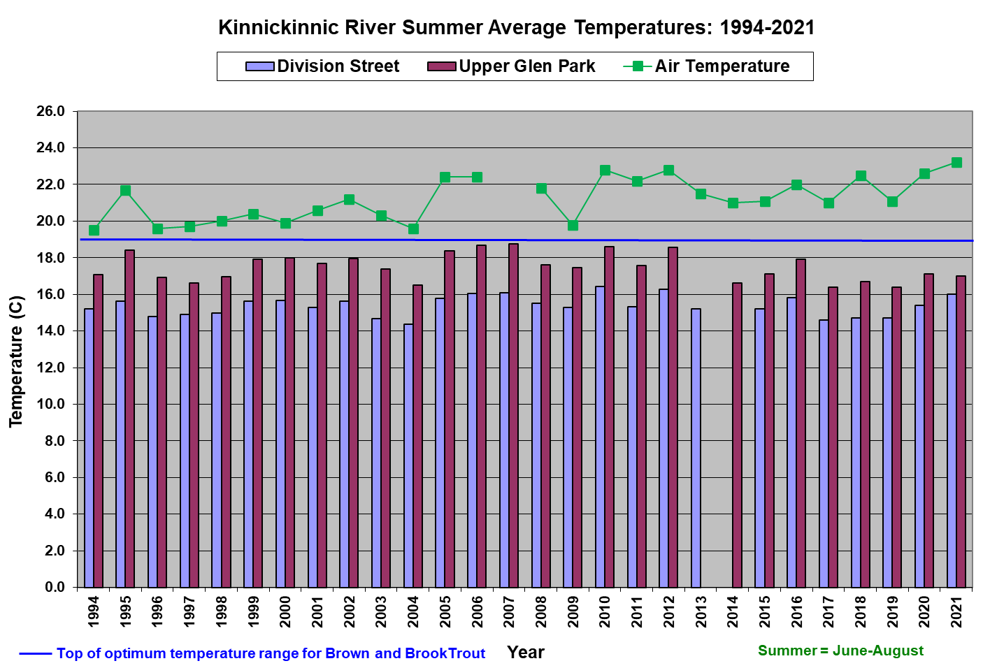

Figure 6. Kinnickinnic River summer average temperatures at Division Street and Upper Glen Park, 1994-2021.

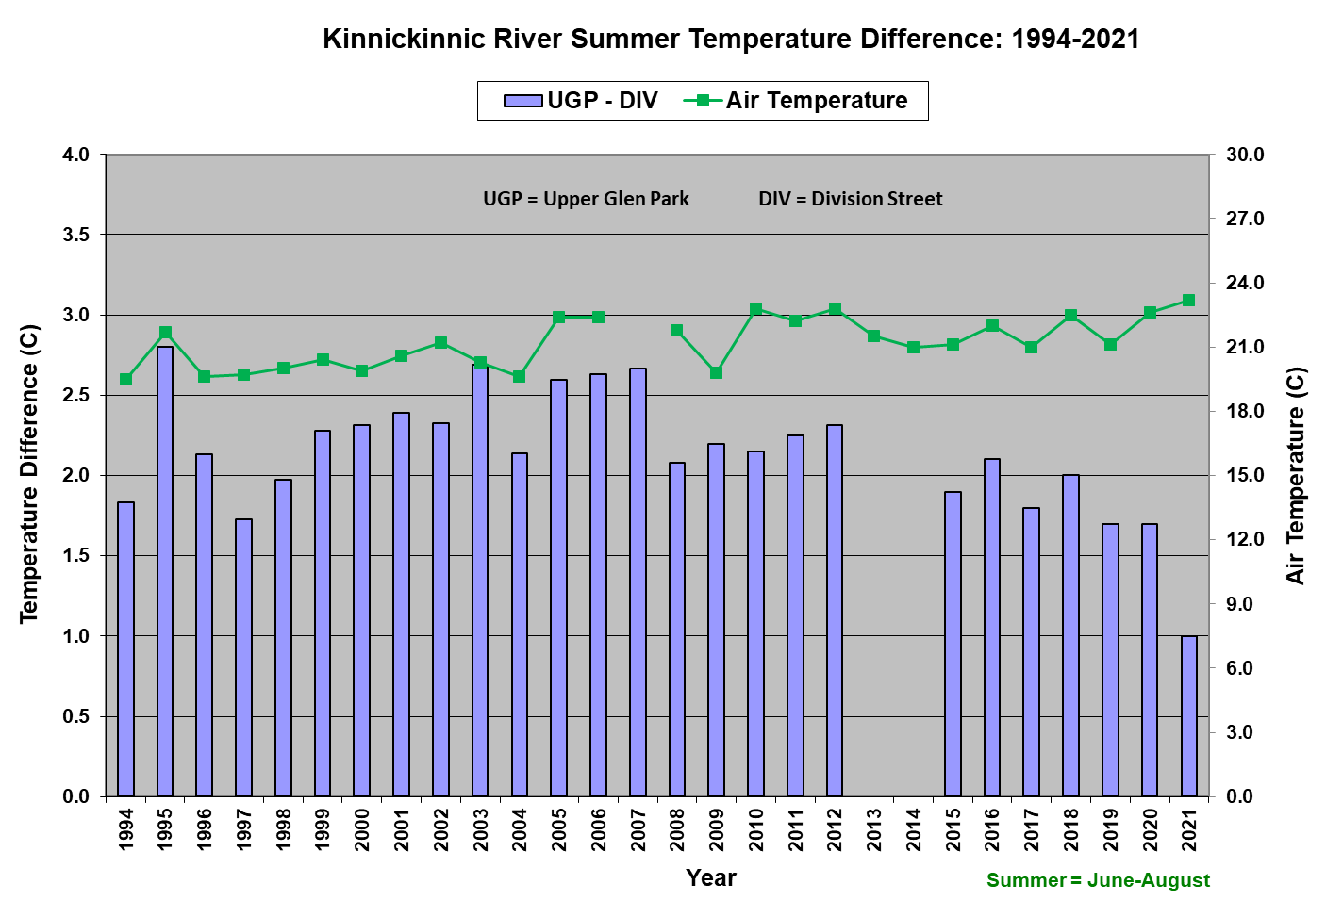
Figure 7. Kinnickinnic River summer average temperature difference between Division Street and Upper Glen
Park, 1994-2021.

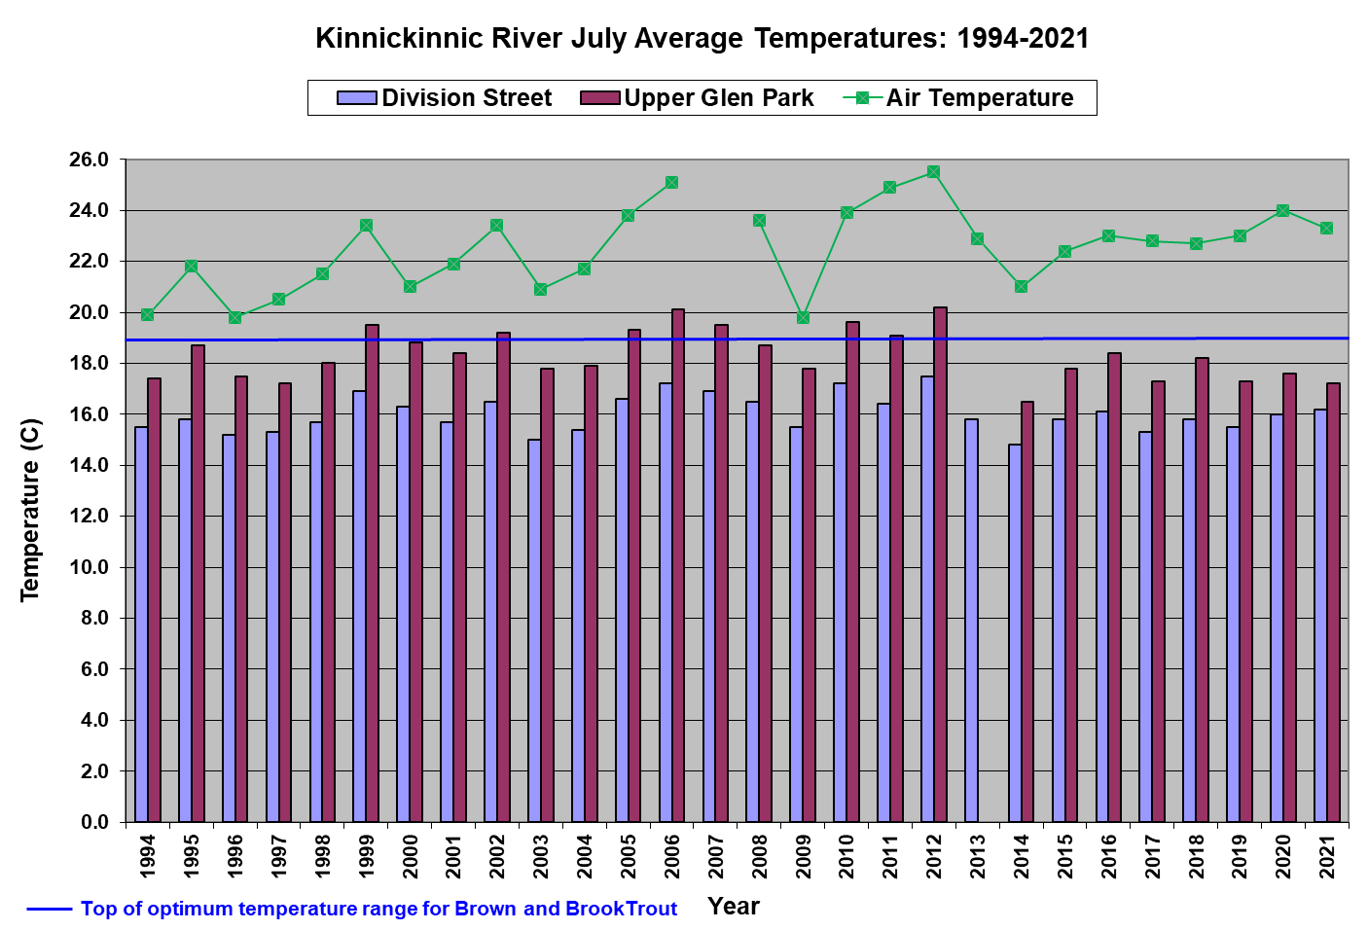

Figure 8. Kinnickinnic River July average temperatures at Division Street and Upper Glen Park, 1994-2021.

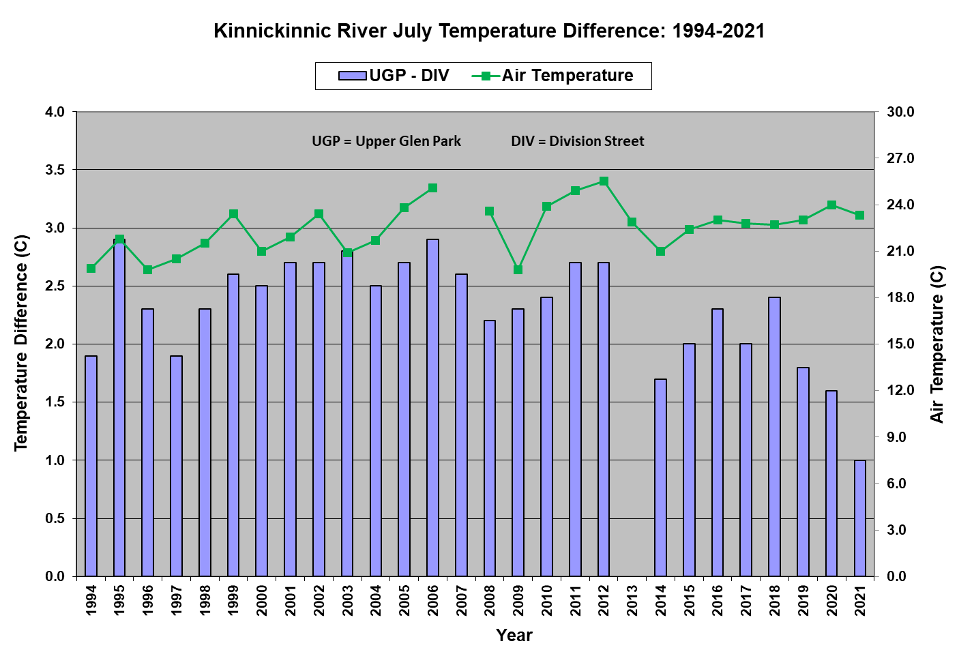
Figure 9. Kinnickinnic River July average temperature difference between Division Street and Upper Glen
Park, 1994-2021.

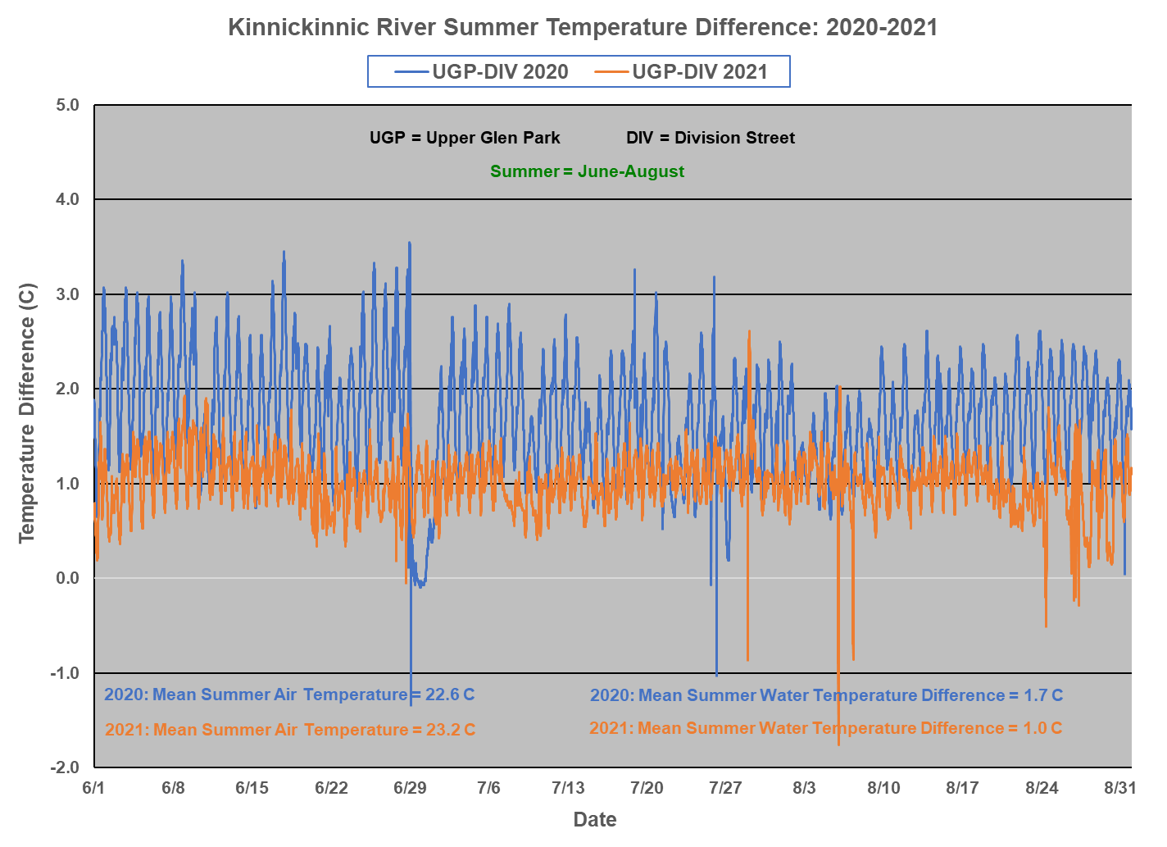
Figure 10. Kinnickinnic River summer temperature difference between Division Street and Upper Glen
Park in 2020 and 2021.

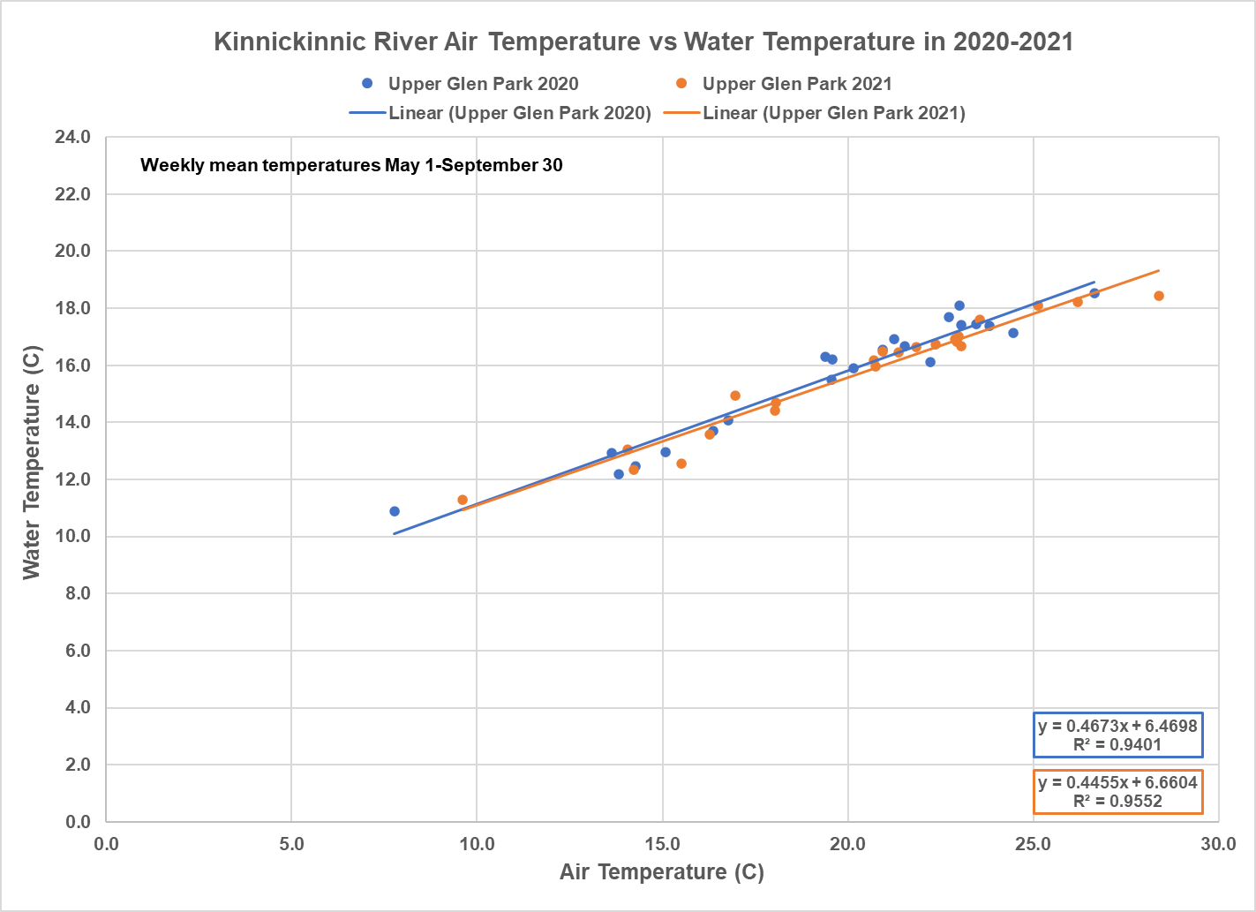

Figure 11. Relationships between Kinnickinnic River air and water temperatures at Upper Glen Park in
2020 and 2021.

Ongoing Thermal Impact of the Junction Falls Dam and Lake George

The 2021 summer average temperature difference of 1.0º C (1.8° F) between Division Street and Upper Glen Park shows the ongoing thermal impact of the Junction Falls Dam and Lake George. To better understand and document the thermal impact of Lake George, Kiap-TU-Wish installed an additional temperature logger at the downstream end of the lake in July 2021.

The temperature difference between Lake George and Division Street during July-August 2021 is shown in Figure 12. This difference typically ranged from 0.5º-1.5º C (0.8-2.7° F), averaging 1.0º C (1.8° F). Figure 13 provides a comparison of Kinnickinnic River temperatures at Division Street, Lake George, and Upper Glen Park in July and August 2021. During the July-August period, the temperature at Division Street was consistently cooler than the temperature in Lake George and at Upper Glen Park. The average temperature at Division Street was 15.9º C (60.7° F), with only 2.3% of recorded temperatures exceeding 19º C. In contrast, the average temperature in Lake George was 16.9º C (62.5° F), with 9.3% of recorded temperatures exceeding 19º C. At Upper Glen Park, the average temperature of 16.9º C (62.5° F) was identical to that in Lake George, with 8.2% of recorded temperatures exceeding 19º C.

In 2021, the July-August average temperature difference of 1.0º C (1.8° F) between Division Street and Lake George was identical to the July-August average temperature difference of 1.0º C (1.8° F) between Division Street and Upper Glen Park, suggesting that Lake George is responsible for the ongoing warming influence on the lower Kinni, post-drawdown.

Pre-drawdown (prior to October 2020), any summer cooling influence of the South Fork of the Kinnickinnic River (South Fork), with its confluence immediately downstream of Lake George and the Junction Falls Dam, was negated by the presence of Lake Louise and its warming effect. Post-drawdown, this Lake Louise warming effect was removed, potentially allowing the colder South Fork water to help offset the remaining thermal impact of Lake George. In July-August 2021, the average temperature of the South Fork was 15.9º C (60.5° F), identical to the upstream average temperature of the Kinni at Division Street 15.9º C (60.7° F). The colder water contribution from the South Fork did not reduce the average 1.0 C (1.8° F) warming effect of Lake George, as the average temperatures at Division Street, Lake George, and Upper Glen Park were 15.9º C (60.7° F), 16.9º C (62.5° F), and 16.9º C (62.5° F), respectively. However, there was a slight improvement (reduction) in the percentage of July-August 2021 temperatures exceeding 19º C, from 9.3% at Lake George to 8.2% at Upper Glen Park, perhaps due in part to the South Fork’s contribution of colder water.

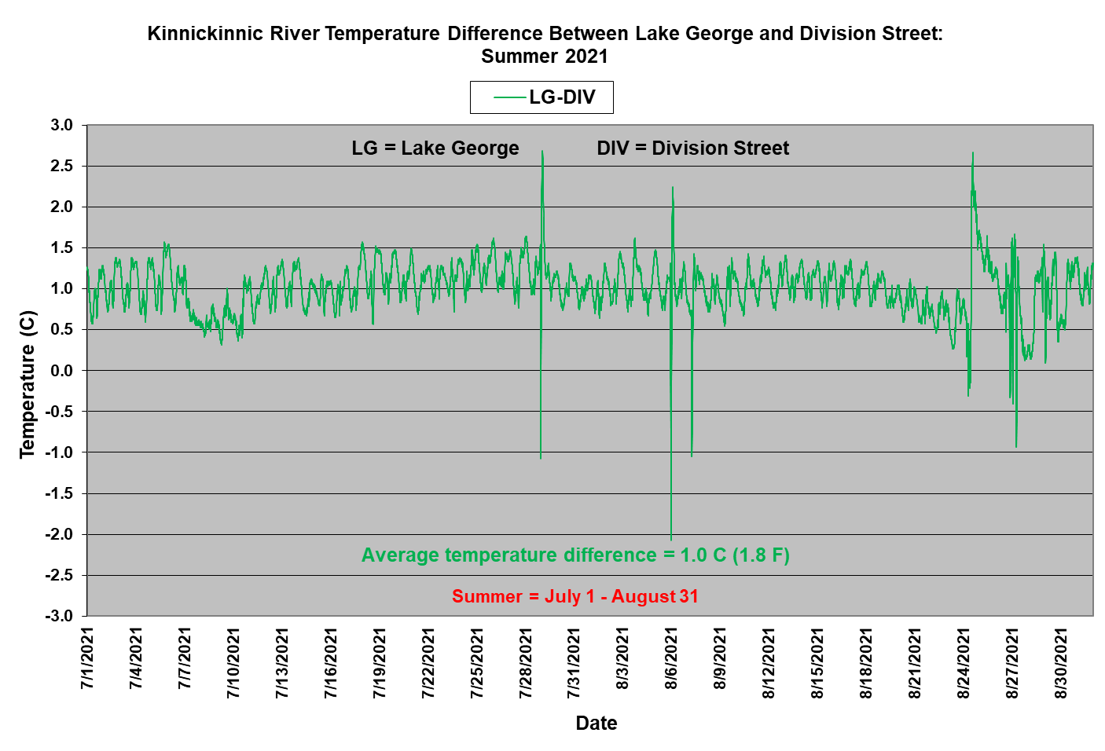
Figure 12. Kinnickinnic River temperature difference between Lake George and Division Street during
July-August 2021.

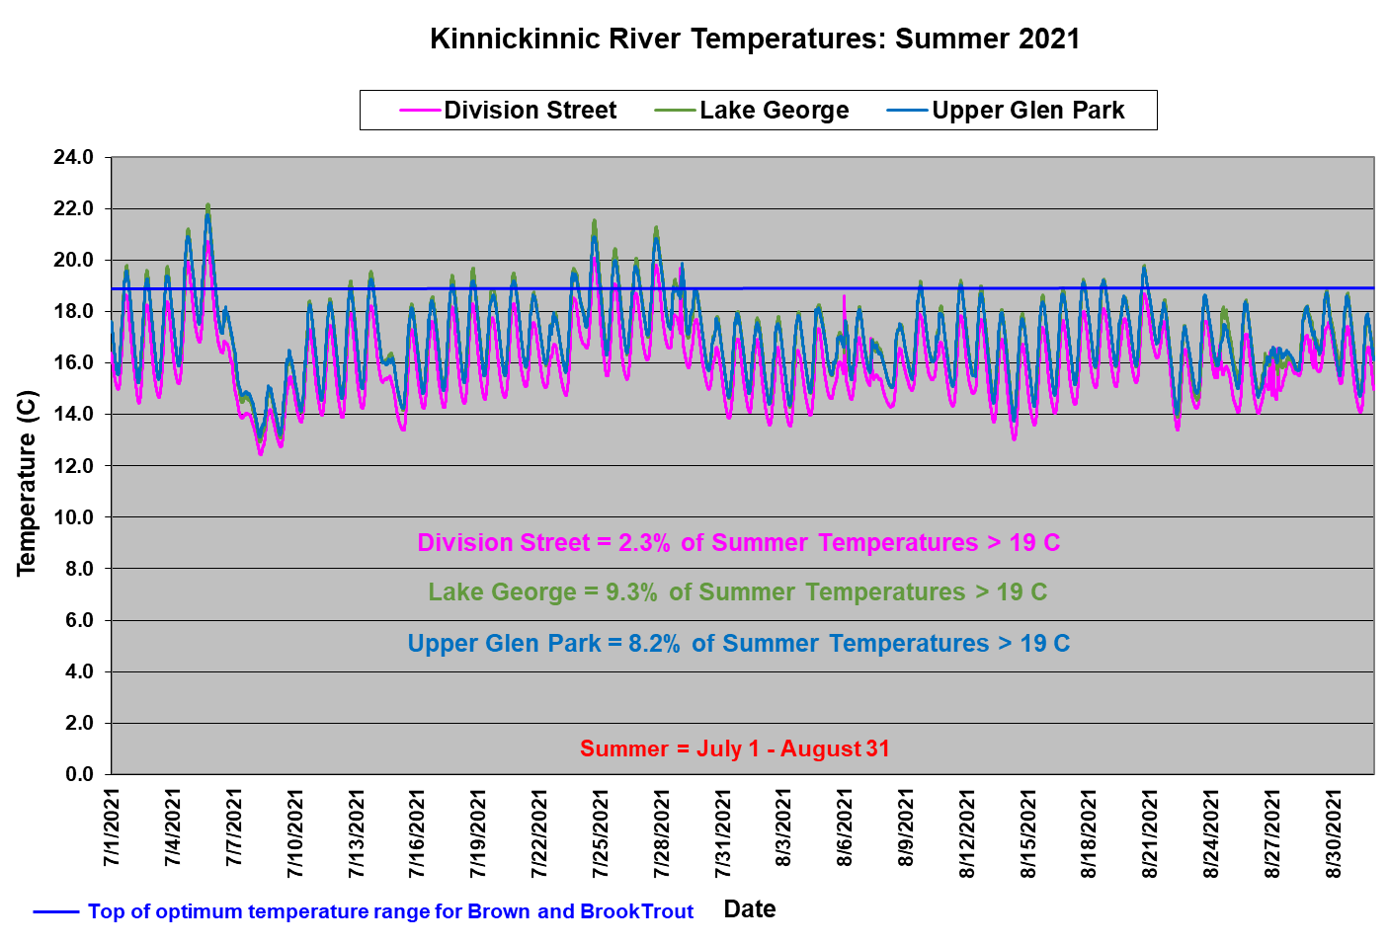

Figure 13. Kinnickinnic River temperatures at Division Street, Lake George, and Upper Glen Park during
July-August 2021.

Future Kinnickinnic River Monitoring

While post-drawdown temperature improvements were noted in the lower Kinni in the summer of 2021, long-term temperature monitoring by Kiap-TU-Wish in 2022 and beyond will further document the thermal benefits related to Powell Falls Dam removal and Kinnickinnic River restoration through the former Lake Louise. Such monitoring will also better define the ongoing thermal impacts of the Junction Falls Dam and Lake George. The Kiap-TU-Wish temperature monitoring network is a key element of the Kinnickinnic River Monitoring Plan, created in May 2021. This plan will allow the City of River Falls to evaluate ecological outcomes associated with the Powell Falls Dam removal and Kinni restoration process and use those findings to enhance strategies for the ultimate removal of the Junction Falls Dam.

Document prepared by Kent Johnson, Kiap-TU-Wish Chapter, Trout Unlimited
March 31, 2022

Krider, L.A., J.A. Magner, J. Perry, B. Vondracek, and L.C. Ferrington. 2013. Air-water temperature relationships in the trout streams of southeastern Minnesota’s carbonate-sandstone landscape. JAWRA 49 (4): 896-907.

