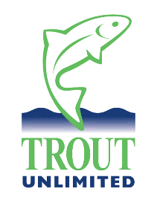
Kinni River Macroinvertebrate Communities: Angler Comparisons of Past to Present

One of the primary goals of the 2022-2025 Kinnickinnic River Macroinvertebrate Survey is to compare the historical condition of the Kinnickinnic River macroinvertebrate community (based on the Garry/Kiap 2001/2002 river-wide surveys) to the current condition, 20+ years later. To help us make this comparison, we’d like your input, as requested below. If more space is needed, please continue your responses on another sheet of paper.

- Based on your Kinni angling experiences and/or general river observations, what are your recollections of past Kinni macroinvertebrate species/hatches that may no longer be as prevalent?

Type of insect(s) (Latin name or common angler name):

General location(s) where you’ve noticed a decreased presence:

- Based on your Kinni angling experiences and/or general river observations, are there any current Kinni macroinvertebrate species/hatches that are more abundant than in the past?

Type of insect(s) (Latin name or common angler name):

General location(s) where you’ve noticed an increased presence:

- Please let us know if you have any detailed notes on hatch information and/or macroinvertebrate presence/absence that you would be willing to share with us (or feel free to return with the survey).

- Are there any other observations (past or present) on the condition of the Kinni that you’d like to share with us?

- As our Trout Unlimited chapters work toward river protection and restoration, what are your concerns about present and future impacts on the Kinni?

Your contact Information (if you care to share; anonymous is also fine):

Name:

E-Mail Address:

Please return the survey to:

Kent Johnson
1403 Birch Drive
Hudson, WI 54016

E-Mail: d.kent.johnson@gmail.com
(Also steer any questions to this e-mail address)

Thanks so much for your observations and feedback!

